ENGR 421 Homework 3

Umur Demircioglu

64609

* In this part of the code libraries are imported. Data is read using pandas library. I created ytruth and yruthtest for confusion matrix.

* Inside a for loop divided the data into two training and test sets, calculated mean and printed the results. Then I used imshow function to draw the letters however first I needed to use numpy reshape function to make the format correct.

* In this part I defined my score function using the equation in the book.

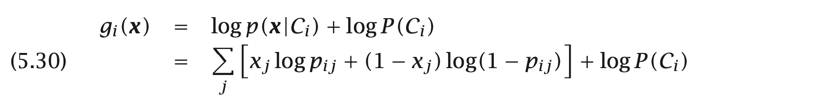

After defining the score function I used It inside two different for loops one for train and one for test set. I used these for loops for prediction. I used append to add my predictions to two lists ypredtrain and ypredtest. Finally, I printed the confusion matrix using pandas library.

Output

